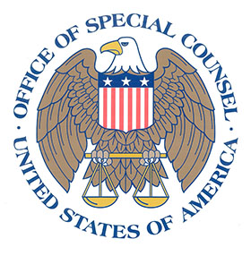 | U.S. Office of Special Counsel  Follow-Up Mediation Survey

Thank you for participating in our follow-up survey. Your feedback is important.

For the purpose of this survey, the word “mediation” refers to all interactions with the OSC ADR Unit.

1. Did your OSC mediation result in a settlement agreement?

Yes
No
N/A
Don’t Know

If YES: | If NO, N/A, or DON’T KNOW:
2. My understanding of the settlement when I signed it was correct.  Agree Strongly  Agree Somewhat  Neither  Disagree Somewhat  Disagree Strongly  N/A  Please explain your answer.  _____________________________________ | 2. My workplace situation improved because I went through mediation.  Agree Strongly  Agree Somewhat  Neither  Disagree Somewhat  Disagree Strongly  N/A  Please explain your answer.  _____________________________________
3. I am satisfied with the settlement.  Agree Strongly  Agree Somewhat  Neither  Disagree Somewhat  Disagree Strongly  N/A | 3. I would use mediation in the future.  Agree Strongly  Agree Somewhat  Neither  Disagree Somewhat  Disagree Strongly  N/A
Please explain your answer.  _____________________________________  4. My workplace situation improved because I went through mediation.  Agree Strongly  Agree Somewhat  Neither  Disagree Somewhat  Disagree Strongly  N/A  Please explain your answer.  _____________________________________  5. I would use mediation in the future.  Agree Strongly  Agree Somewhat  Neither  Disagree Somewhat  Disagree Strongly  N/A  6. I would recommend mediation at OSC to a colleague or friend.  Agree Strongly  Agree Somewhat  Neither  Disagree Somewhat  Disagree Strongly  N/A | 4. I would recommend mediation at OSC to a colleague or friend.  Agree Strongly  Agree Somewhat  Neither  Disagree Somewhat  Disagree Strongly  N/A

